**Custom Training**

**Day 4**

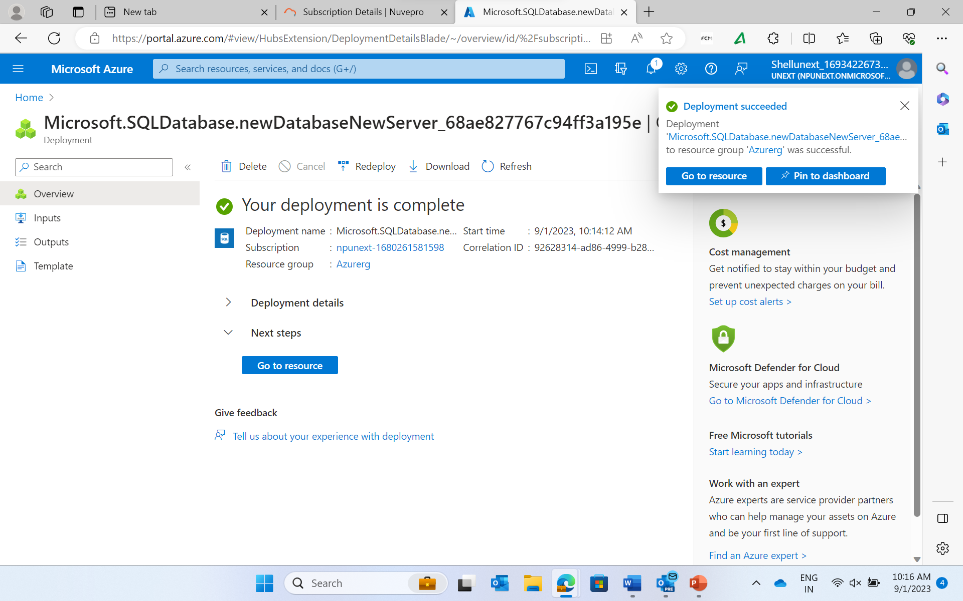

CREATE TABLE Customers ( CustomerID INT PRIMARY KEY, FirstName VARCHAR(50), LastName VARCHAR(50), Email VARCHAR(100) );

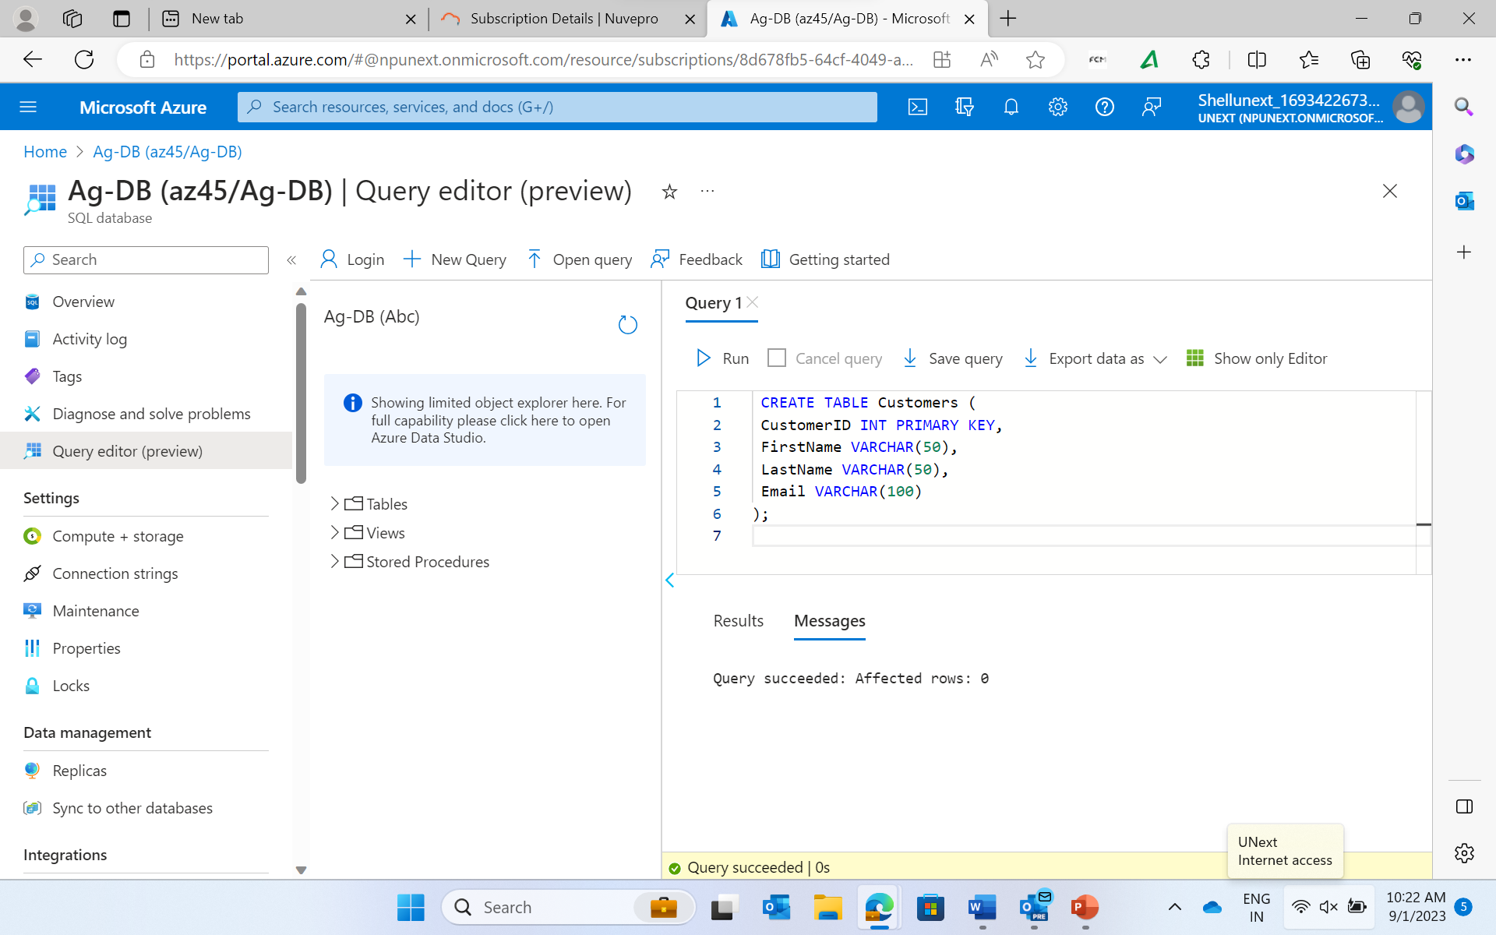

CREATE TABLE Orders ( OrderID INT PRIMARY KEY, CustomerID INT, OrderDate DATE, TotalAmount DECIMAL(10, 2), FOREIGN KEY (CustomerID) REFERENCES Customers(CustomerID) );

Insert into Customers values (1, 'John', 'Doe', 'john.doe@example.com');

Insert into Customers values (2, 'Jane', 'Smith', 'jane.smith@example.com');

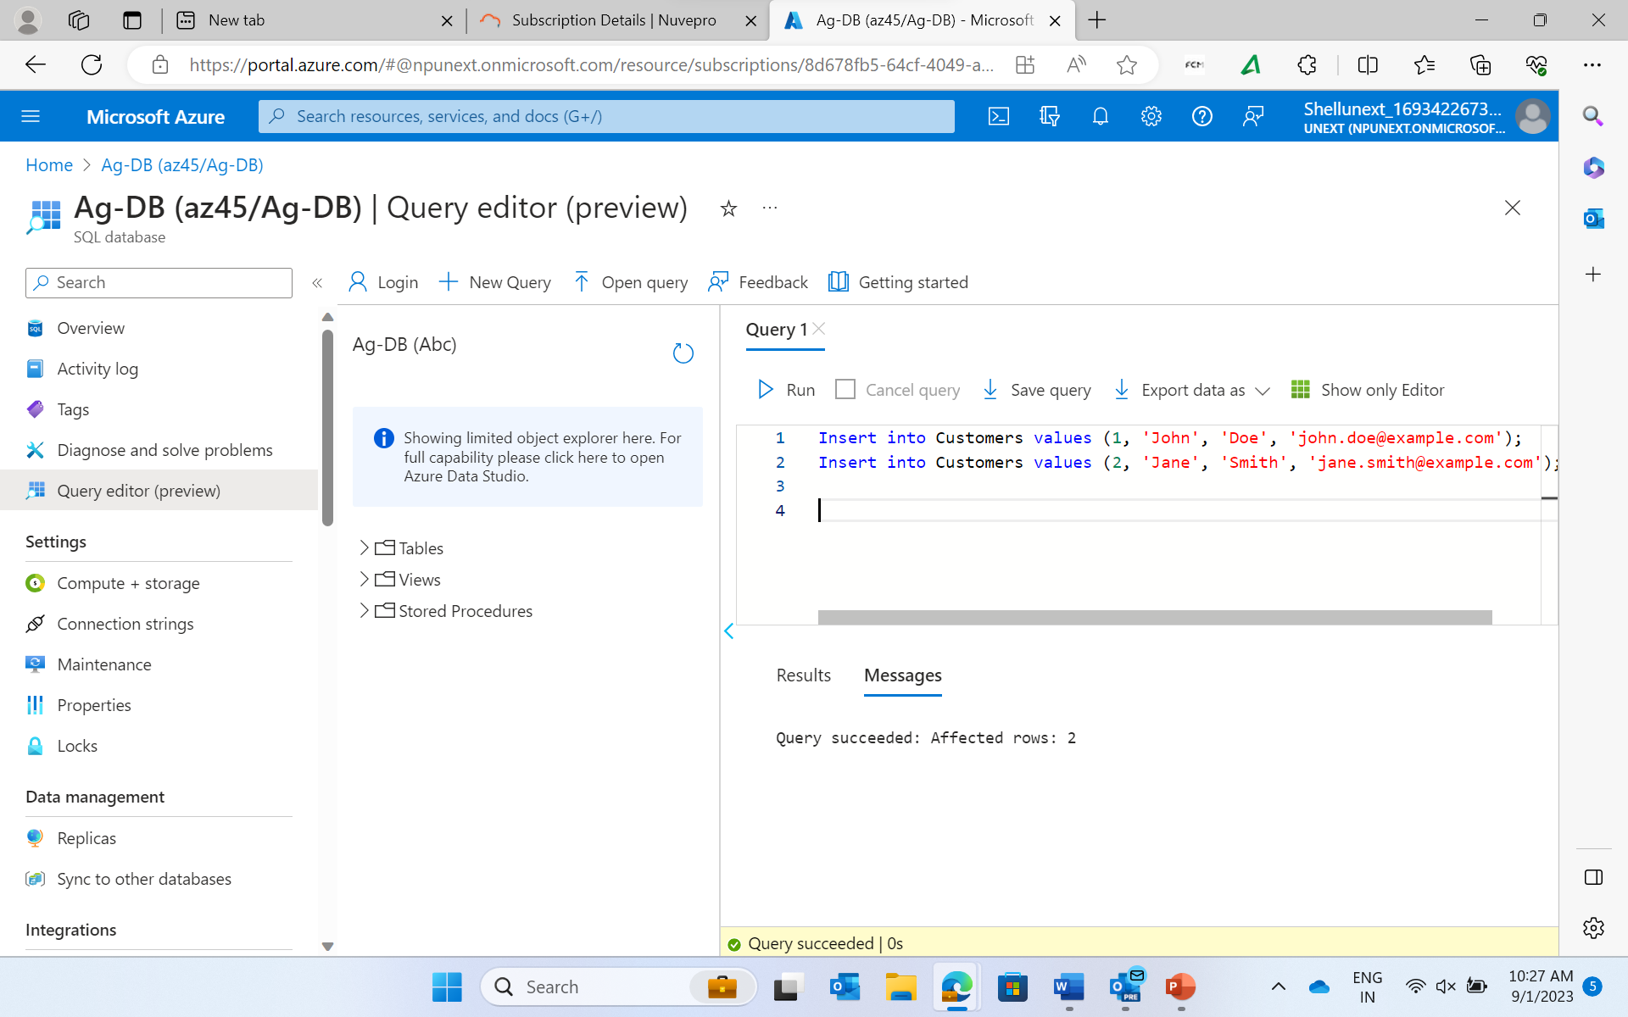

Insert into Orders values (1, 1, '2023-08-01', 50.00);

Insert into Orders values (2, 2, '2023-08-15', 75.00);

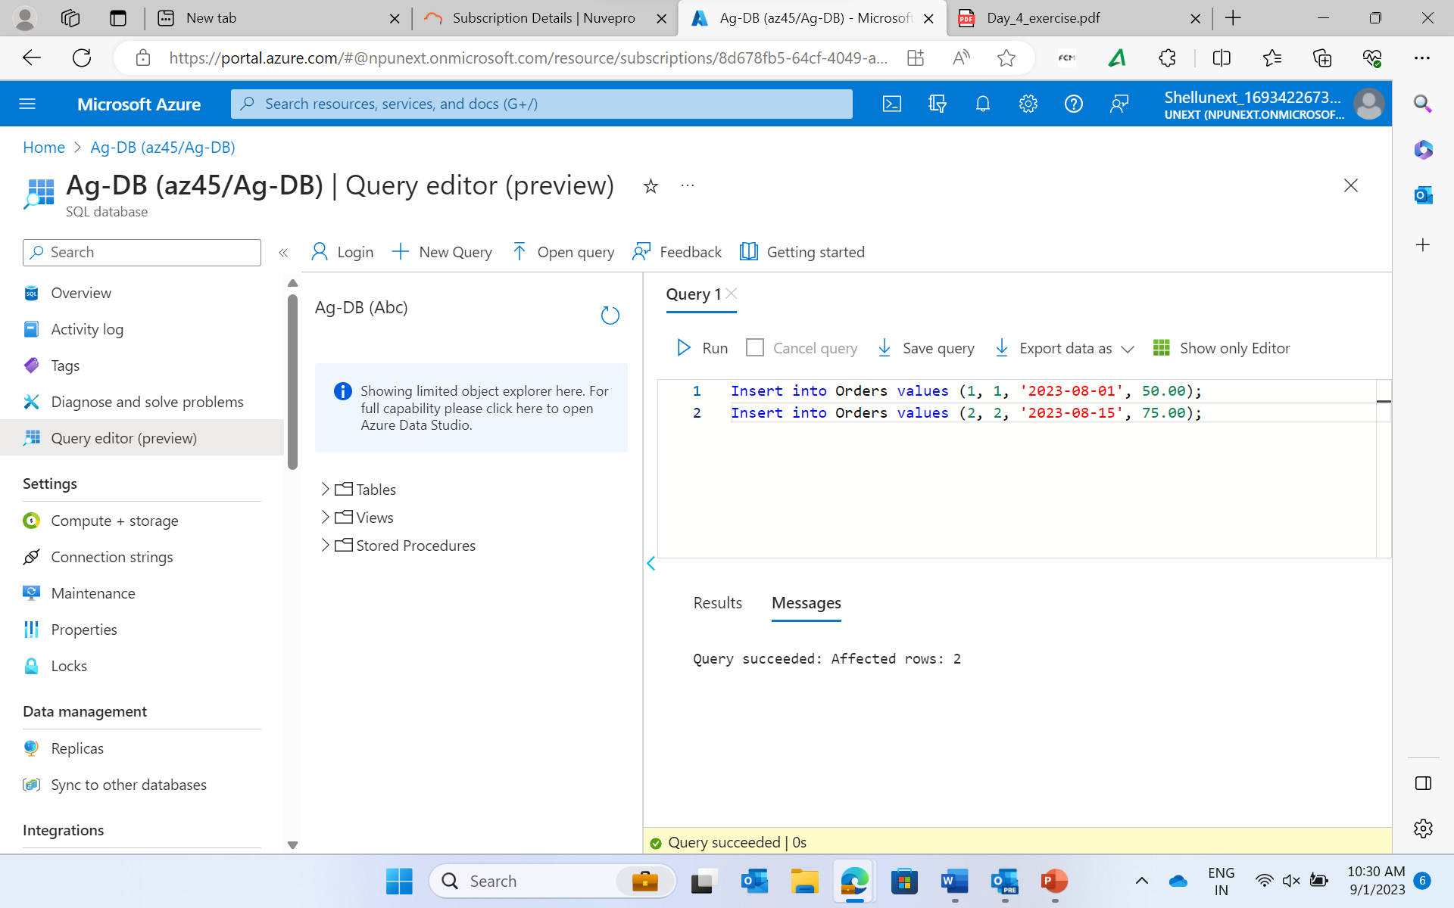

Select * from Customers;

Select * from Orders;

**Joins**

**Inner Join**

Select Customers.* , Orders.* from Customers INNER JOIN on Customers.CustomerID = Orders.CustomerID;

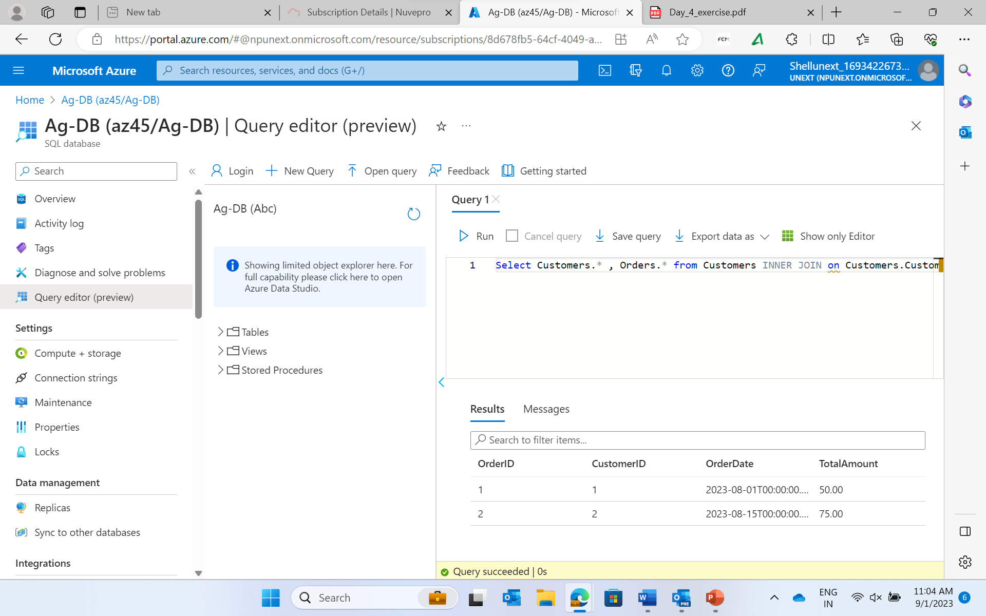

SELECT Customers.*, Orders.* FROM Customers LEFT JOIN Orders ON Customers.CustomerID = Orders.CustomerID;

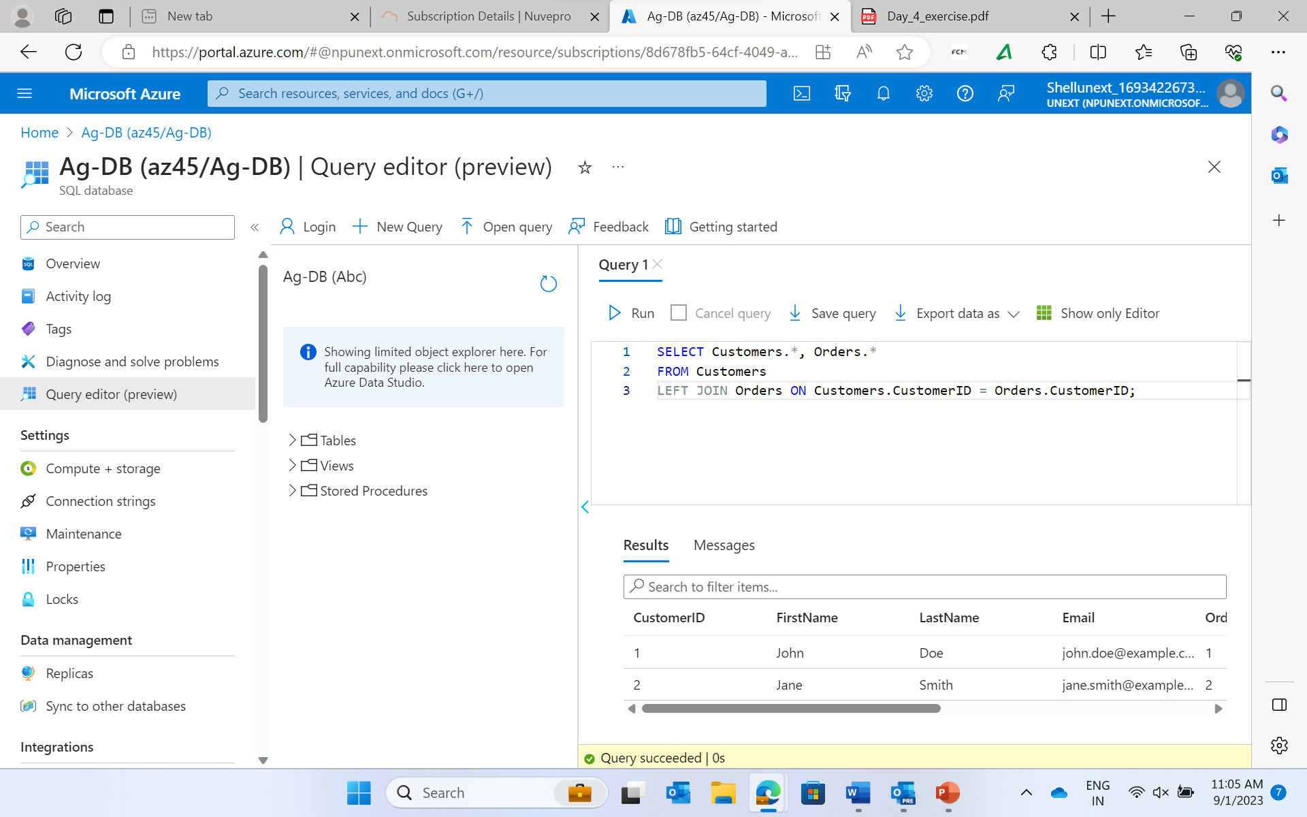

**Union**

SELECT CustomerID FROM Customers

UNION

SELECT CustomerID FROM Orders;

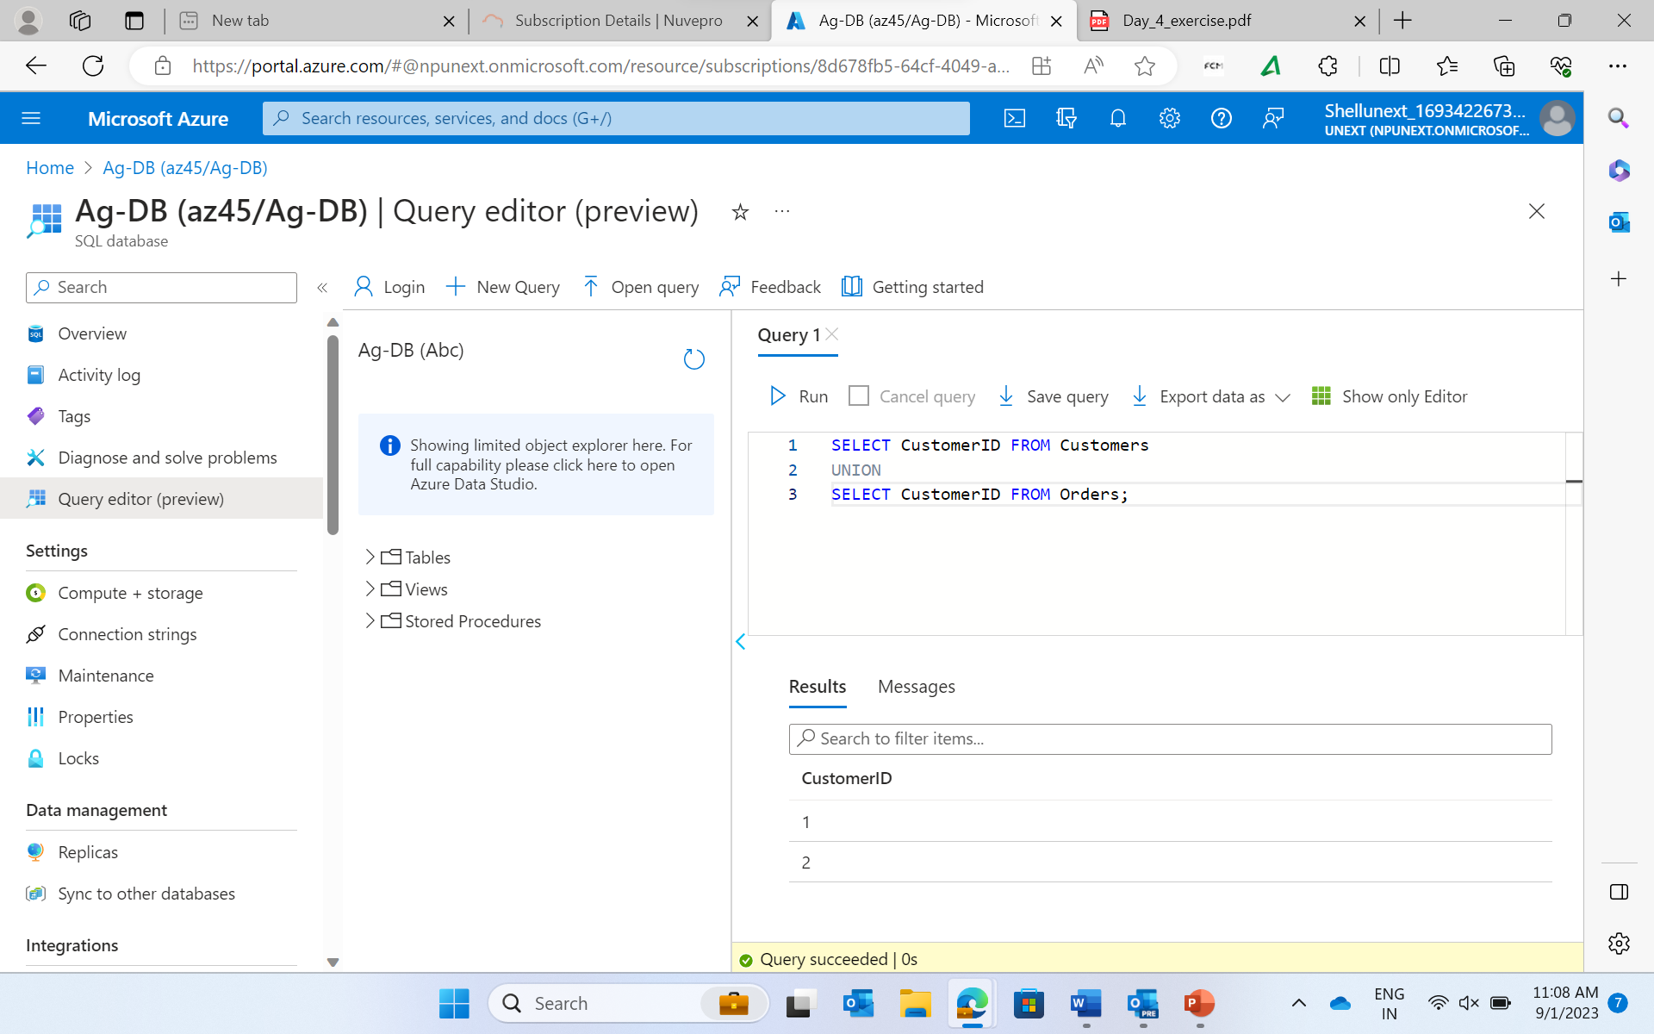

**Union All:**

SELECT CustomerID FROM Customers

UNION ALL

SELECT CustomerID FROM Orders;

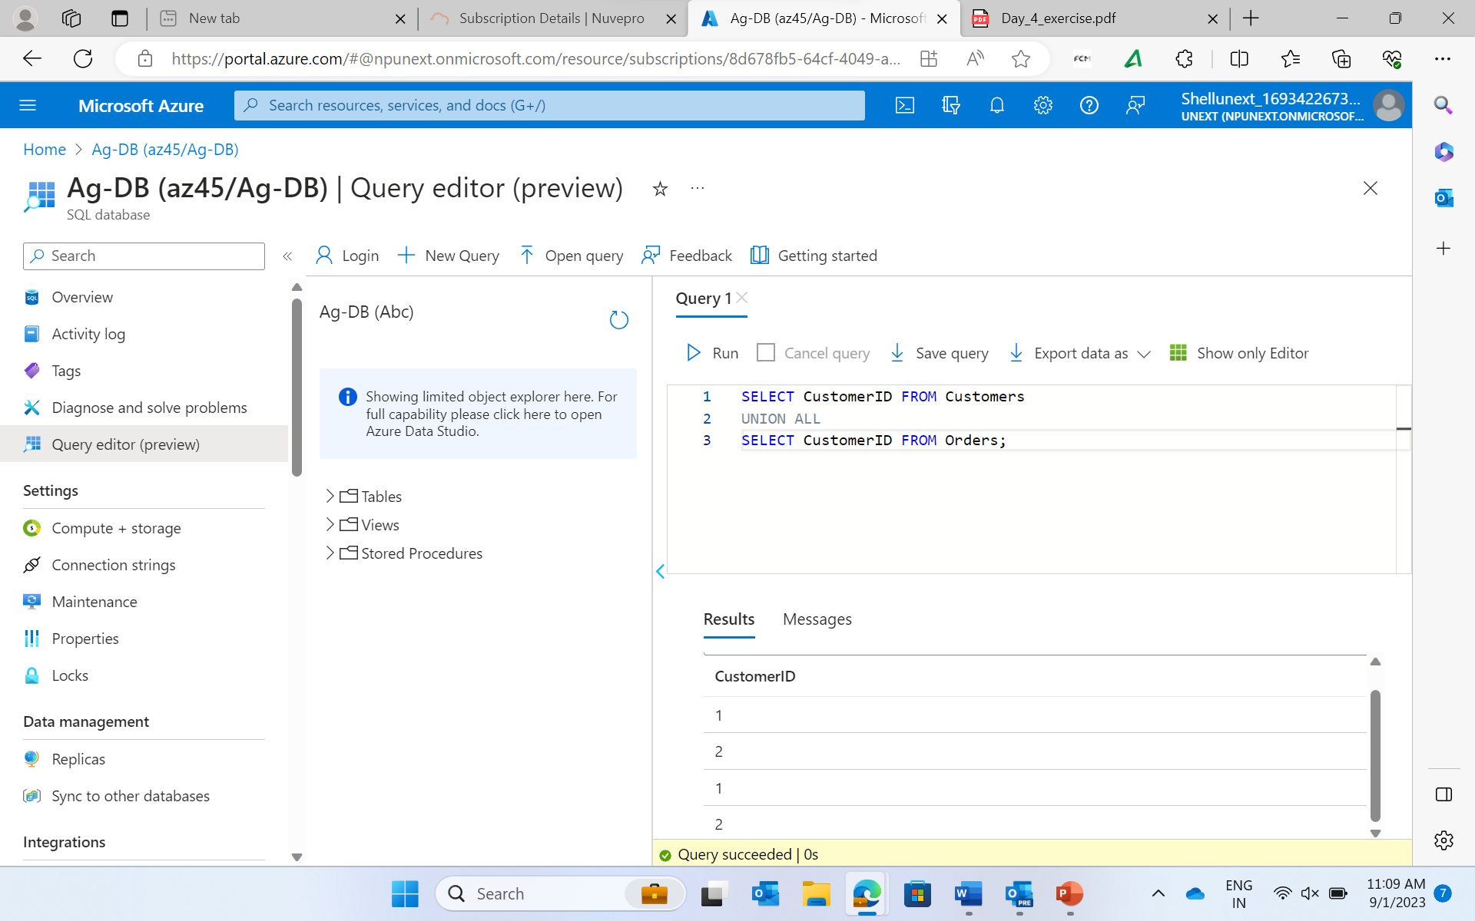

**Intersect**

SELECT CustomerID FROM Customers

INTERSECT

SELECT CustomerID FROM Orders;

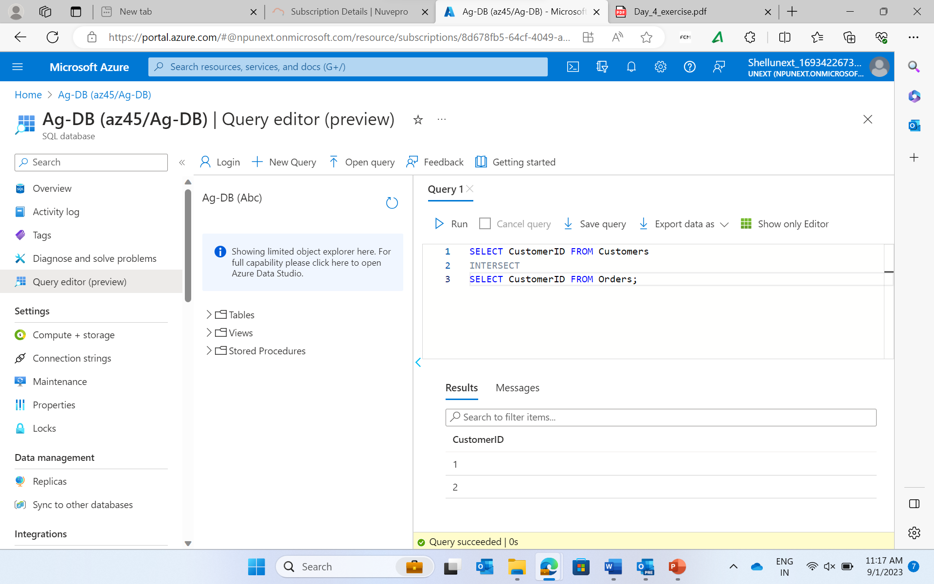

**Subqueries**

SELECT * FROM Orders WHERE CustomerID IN

(SELECT CustomerID FROM Customers WHERE Email = 'john.doe@example.com');

Create table Galleries (Id int , City varchar(20));

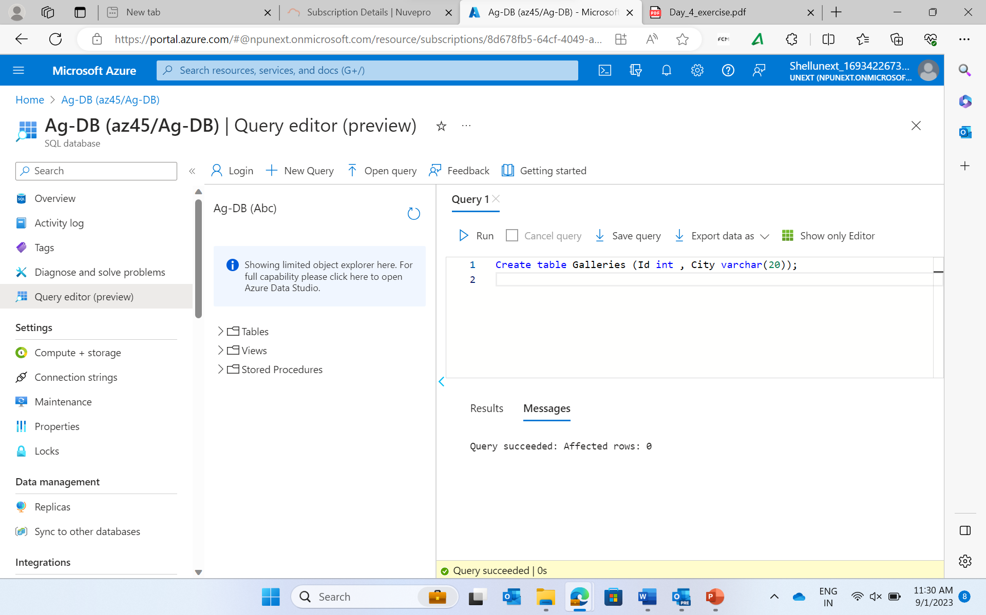

Create table Paintings

(Id int , Name varchar(30), Gallery_id int, Price int);

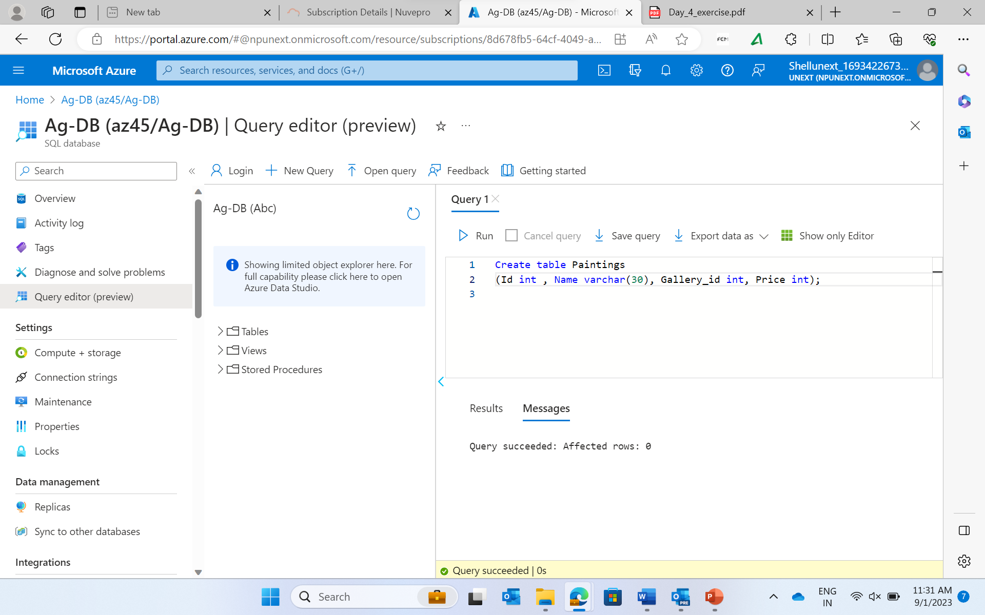

Insert into Galleries Values(1, 'Jaipur');

Insert into Galleries Values(2, 'Kolkata');

Insert into Galleries Values(3, 'Madhubani');

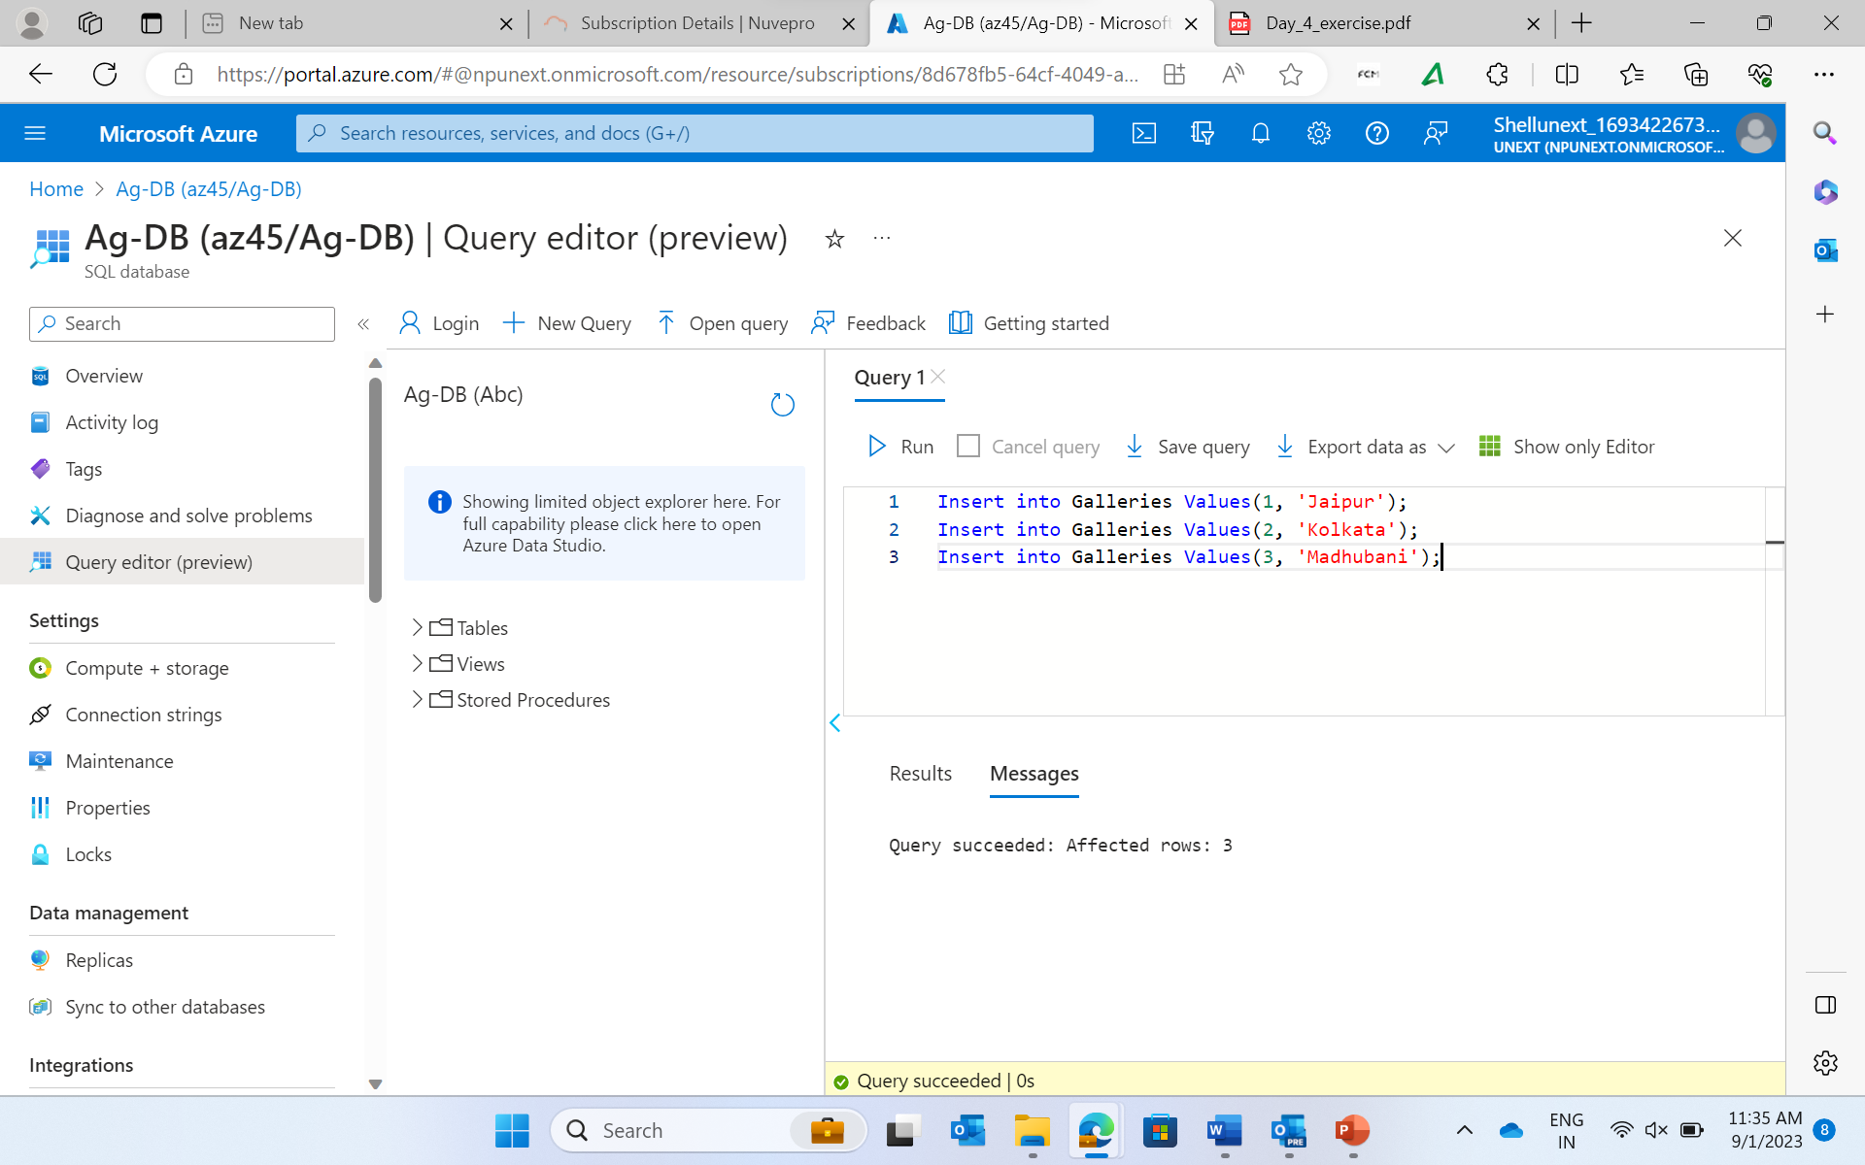

Insert into Paintings Values(1, 'Patterns',3,5000);

Insert into Paintings Values(2, 'Ringer',1,4500);

Insert into Paintings Values(3, 'Gift',1,3200);

Insert into Paintings Values(4, 'Violin Lessons',2,6700);

Insert into Paintings Values(5, 'Curiosity',2,9800);

